Example No 1:

Input:
using System;

namespace Abdullah_Sadiq_Cp_Lab_6
{
class Program
{
static void Main(string[] args)
{
for (int i = 0; i <= 10; i++)
{ Console.Write(i + ","); }
}
}
}
Output:
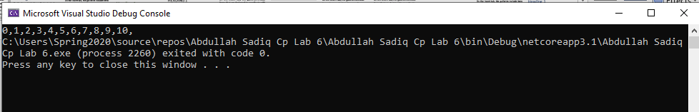
Example no 2
Input:
using System;

namespace Abdullah_Sadiq_Cp_Lab_6
{
class Program
{
static void Main(string[] args)
{
for (int i = 1, sum = 1; i <= 128; i = i*2, sum *=i)
{
Console.WriteLine("i = {0}, sum = {1}", i, sum);
}
}
}
}
Output:
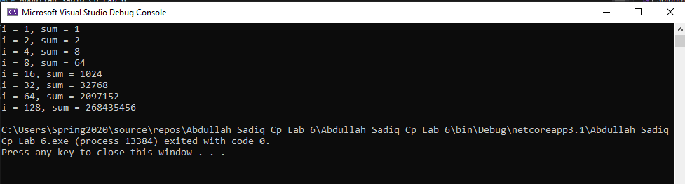
Example no 3
Input:
using System;

namespace Abdullah_Sadiq_Cp_Lab_6
{
class Program
{
static void Main(string[] args)
{
for (int i = 1; i <= 10; i++)
{

Console.WriteLine("2x{0} ={1}", i,i * 2);

}
}
}
}
Output:
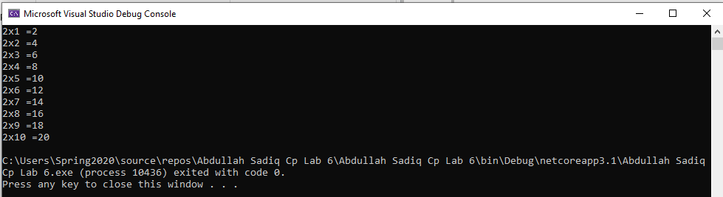
Example No 04
Input:
using System;

namespace Abdullah_Sadiq_Cp_Lab_6
{
class Program
{
static void Main(string[] args)
{
for (int small = 1, large = 10; small<large; small++,large--)
{
Console.WriteLine(small + " " + large );
}
}
}
}
Output:
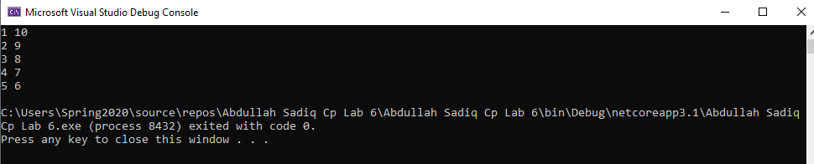
Example No 05
Input:
using System;

namespace Abdullah_Sadiq_Cp_Lab_6
{
class Program
{
static void Main(string[] args)
{
for (int i = 0; i < 3; i++)
{
for (int j = 0; j < 3; j++)
{
Console.Write("*" + " ");

}
Console.WriteLine("");
}
}
}
}
Output:
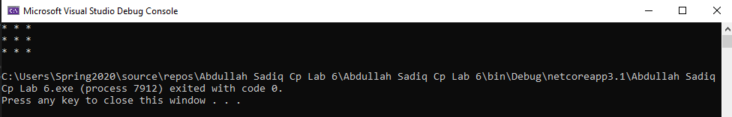

Task No 01: Cube series without using power math function. (Use For loop)
Input:
using System;

namespace Abdullah_Sadiq_CP_Home_Tasks
{
class Program
{
static void Main(string[] args)
{
for (int i = 1; i <=10; i++)
{
Console.WriteLine("The Cube of {0} is {1}", i, i*i*i);
}
}
}
}
Output:
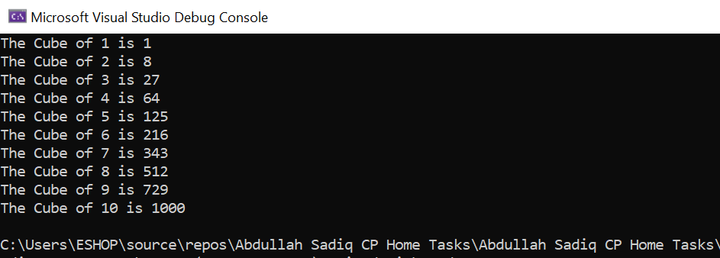
Task No 02: Square Series without using power math function (use For loop).
Input:
using System;

namespace Abdullah_Sadiq_CP_Home_Tasks
{
class Program
{
static void Main(string[] args)
{
for (int i = 1; i <=10; i++)
{
Console.WriteLine("The Square of {0} is: {1}", i, i*i);
}
}
}
}

Output:
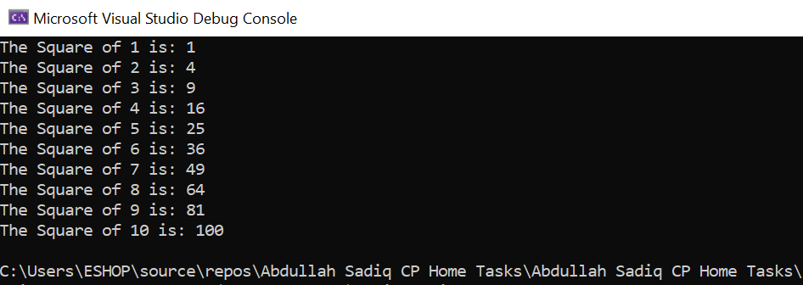
Task No 03: Repeatedly print the value of the variable x Value, decreasing it by 0.5 each time, as long as the x value remains Positive.
Input:
using System;

namespace Abdullah_Sadiq_CP_Home_Tasks
{
class Program
{
static void Main(string[] args)
{
double num;
Console.Write("Enter the Value of x: ");
num = Convert.ToDouble(Console.ReadLine());

for (double i = num; i >0;)
{
Console.WriteLine("{0,-5:0.0}- 0.5 = {1,-5:0.0}", i, i -= 0.5);
}
}
}
}
Output:
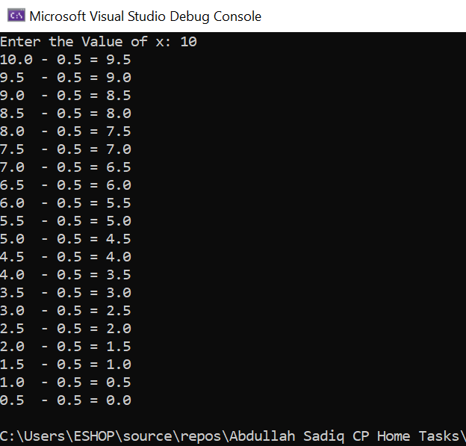
Task No 04: Print the square roots of the first 25 odd positive integers.
Input:
using System;

namespace Abdullah_Sadiq_CP_Home_Tasks
{
class Program
{
static void Main(string[] args)
{
Console.WriteLine("Square root of first 25 odd positive integers");
for (int i = 1; i < 50; i++)
{
Console.WriteLine("The Square Root of {0,-2:0} is: {1,-5:0.0}", i, Math.Sqrt(i));
i += 1;
}
}
}
}

Output:
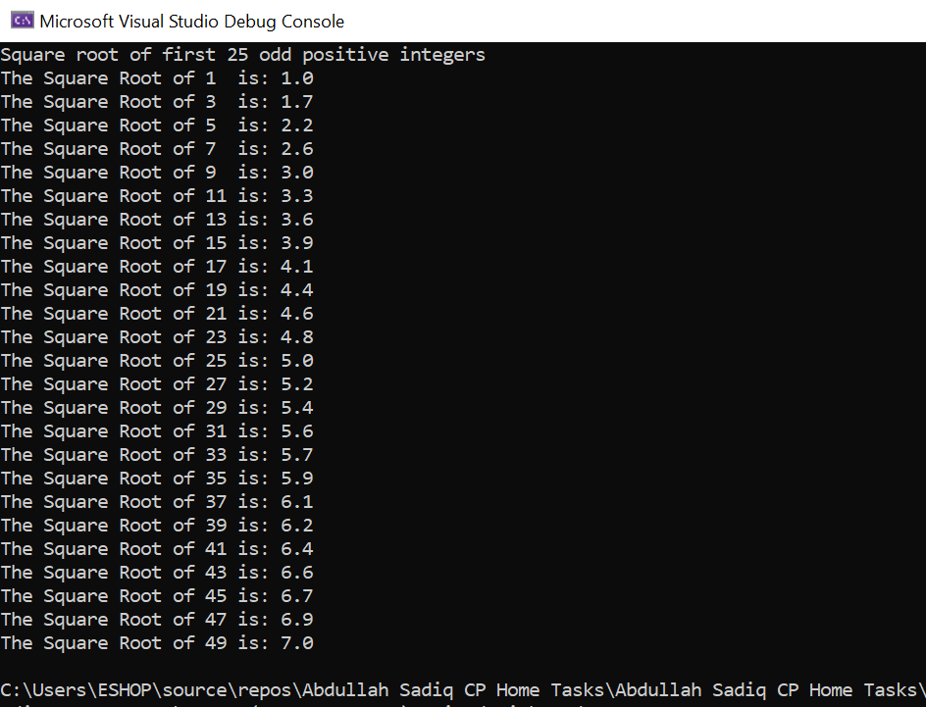

Task No 05: Make a game in C#, in which give 5 tries to the user to guess the value of the number.
Input:
using System;

namespace Abdullah_Sadiq_CP_Home_Tasks
{
class Program
{
static void Main(string[] args)
{
int secret = 69, value, guess = 1;
Console.WriteLine("\t-Secret Number Game-");
for (int i = 0; i < 5; guess++, i++)
{
Console.WriteLine("\nEnter a Secret Number:");
value = int.Parse(Console.ReadLine());
if (value == secret)
{
Console.WriteLine("\nCorrect.\nYou took {0} try to guess a Secret Number.", guess);
break;
}
else
{
Console.WriteLine("\nWrong Answer!\nTry Again.");
}
}
}
}
}

Output:
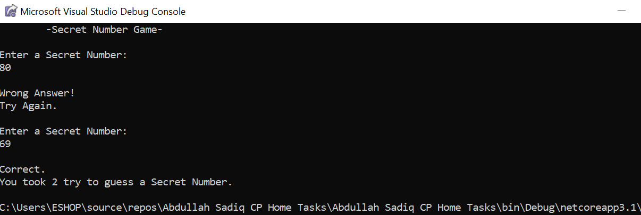

Task No 06: Generate Stars using 2 for loops
Input:
using System;

namespace Abdullah_Sadiq_CP_Home_Tasks
{
class Program
{
static void Main(string[] args)
{
for (int i = 0; i < 4; i++)
{
for (int j = 0; j <= i; j++)
{
Console.Write("* ");
}
Console.WriteLine("");
}
}
}
}

Output:
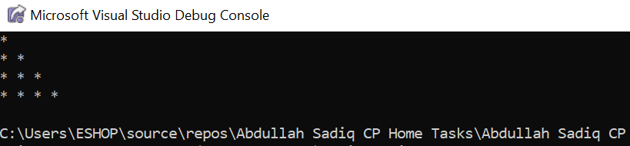

Task No 07: Write a program that reads from the console a positive integer number N (N < 20) and prints a matrix of numbers as N = 3 N = 4.
Input:
using System;

namespace Abdullah_Sadiq_CP_Home_Tasks
{
class Program
{
static void Main(string[] args)
{
Console.WriteLine("Please Enter a Number (Below 20):");
int num = Convert.ToInt32(Console.ReadLine());
if (num <= 20)
{
for (int i = 1; i <= num; i++)
{
for (int j = 0; j < num; j++)
{
Console.Write("{0} ", i + j);
}
Console.WriteLine(" ");
}
}
else
{
Console.WriteLine("Invalid Input!");
}
}
}
}

Output:

